D212 Advanced Data Acquisition

Performance Assessment: Task 1 - Clustering Techniques

Jill Rivera

Western Governors University

Table of Contents

I: Research Question 4

A. Clustering 4

B. Goal 4

II: Technique Justification. 4

A. Technique Analysis 4

B. Assumption 5

C. Python Packages 5

III: Data Preparation. 5

A. Preprocessing Goal. 5

B. Initial Variables. 6

C. Data Preparation 7

IV: Analysis 13

A. K-means 13

B. Clustering Analysis 18

V: Data Summary and Implications 20

A. Accuracy 20

B. Results 24

C. Limitations 24

D. Recommendations 24

VI: Works Cited 24

Figure 1: Categorical Data Variables 7

Figure 2: Continuous Data Variables 7

Figure 3: Importing Python Packages and Defining Constants 7

Figure 4: Importing Data 8

Figure 5: Removing Unrelated Variables 8

Figure 6: Filtering for Churned Customers 8

Figure 7: Filtering for Continuous Numerical Variables 9

Figure 8: Pair Plot 10

Figure 9: Rename Variables 11

Figure 10: Variable Standard Metrics 11

Figure 11: Variable Data Type 12

Figure 12: Exporting Data 12

Figure 13: Removing Highly Correlated Variable 13

Figure 14: Correlation Heatmap 14

Figure 15: Initial Scatter Plot 15

Figure 16: Box Plot of Variables 15

Figure 17: Elbow Method 16

Figure 18: Silhouette Method Determining Cluster Size 17

Figure 19: Initial Model With Two Clusters 18

Figure 20: Final Cluster Model with Three Clusters 19

Figure 21: Silhouette Coefficient 20

Figure 22: Silhouette Analysis Plot Code Part 1 (Pedregosa, Varoquaux, & Gramfort, 2022) 21

Figure 23: Silhouette Analysis Plot Code Part 2 (Pedregosa, Varoquaux, & Gramfort, 2022) 22

Figure 24: Silhouette Plot for k=2 22

Figure 25: Silhouette Plot for k=3 23

Figure 26: Silhouette Plot for k=4 23

# **I: Research Question**: A telecommunications company is trying to develop a better understanding of their customers. They want to know why their customers are churning and how they can develop a better relationship with these customers. To analyze this, the question: What key attributes impact churned customers the most? will be answered.

# Clustering: To answer and analyze the research question posed, a clustering technique called K-Means will be performed. Clustering is the collection of data points that are aggregated together due to their similarities.

# Goal: The goal of this analysis will be to determine two to three key attributes that are impactful to the customer churning from the company. Once these variables are identified, new marketing campaigns and target products can be developed to retain future customers with similar attributes.

# **II: Technique Justification**: K-Means clustering is a simple yet popular method of unsupervised machine learning that can answer this question easily.

# Technique Analysis: K-Means looks for a fixed number (k) of clusters in a data set ((LEDU), 2018) which is exactly what is necessary for this analysis. The k determines the number of centroids you wish to identify and cluster similar data points around. With this analysis, you end up with a distinct set of clusters in which the data points are measured to be a Euclidian distance from a centroid of that cluster. For this analysis, we will be looking for two to three centroids surrounded by data points that are related.

# Assumption: The K-Means clustering technique requires that all the variables are continuous numerical values. This technique is unable to integrate categorical variables due to the structure of the calculations. The data will be prepared based on this assumption.

# Python Packages: The Python programming language in a Jupyter Notebook will be used to perform this analysis. Python is an easy to read, open-source language that can calculate this analysis with only a few helping packages. Pandas will be used to read and export the data set. Numpy will be used to manipulate the data set and conduct exploratory analysis on the data. Matplotlib is a very useful package, used to visualize the data in graphs. Scikit Learn provides the KMeans package with all the necessary formulas as well as StandardScaler which is an algorithm to scale the data. Finally, I will use the Kneed package with KneeLocator to use the elbow method to get the number of clusters for the analysis.

# **III: Data Preparation**: The data preparation was conducted on the data set with the assumptions of K-Means clustering in mind.

# Preprocessing Goal: The major goal to be achieved by preprocessing the data is to reduce the data set to include only continuous numerical variables. This is due to the assumption of the K-Means technique discussed previously.

# Initial Variables: The data set is made up of 10,000 rows of customer data for a telecommunications company. The initial data set includes 50 attributes listed in the tables along with their data type and an example. There are two tables, one for categorical data and the second for continuous data.

|  |  |
| --- | --- |
| **Categorical Data** | |
| **Label** | **Values** |
| Area | Urban, Suburban, Rural |
| Marital | Married, Widowed, Separated, Never Married, Divorced |
| Gender | Female, Male, Nonbinary |
| Churn | Yes, No |
| Techie | Yes, No |
| Contract | Month-to-month, Two Year, One Year |
| Port_modem | Yes, No |
| Tablet | Yes, No |
| InternetService | Fiber Optic, DSL, None |
| Phone | Yes, No |
| Customer_id | Unique customer identification |
| Interaction | Unique alpha-numeric combination |
| UID | Unique alpha-numeric combination |
| City | City Name of Customer |
| Job | Customer’s Profession |
| State | State code |
| County | County of Customer |
| Zip | Zip Code of Customer |
| Lat | Latitude of Customer |
| Lng | Longitude of Customer |
| TimeZone | Time Zone of Customer |
| Multiple | Yes, No |
| OnlineSecurity | Yes, No |
| OnlineBackup | Yes, No |
| DeviceProtection | Yes, No |
| TechSupport | Yes, No |
| StreamingTV | Yes, No |
| PaperlessBilling | Yes, No |
| PaymentMethod | Bank Transfer(automatic), Credit Card (automatic), Mailed Check, Electronic Check |
| Item1 | Survey Response Rank of 1 through 5 |
| Item2 | Survey Response Rank of 1 through 5 |
| Item3 | Survey Response Rank of 1 through 5 |
| Item4 | Survey Response Rank of 1 through 5 |
| Item5 | Survey Response Rank of 1 through 5 |
| Item6 | Survey Response Rank of 1 through 5 |
| Item7 | Survey Response Rank of 1 through 5 |
| Item8 | Survey Response Rank of 1 through 5 |

Figure : Categorical Data Variables

|  |  |  |
| --- | --- | --- |
| **Continuous Data** | | |
| **Label** | **Data Type** | **Example** |
| Population | Int | 8508 |
| Children | Int | 1 |
| Age | Int | 53 |
| Income | Float | 38329.40 |
| Outage_sec_perweek | Float | 10.01 |
| Email | Int | 12 |
| Contacts | Int | 1 |
| Yearly_equip_failure | Int | 1 |
| Tenure | Int | 34 |
| MonthlyCharge | Float | 172.78 |
| Bandwidth_GB_Year | Float | 3379.46 |
| CaseOrder | Int | 5 |

Figure : Continuous Data Variables

# Data Preparation: The following steps were taken to prepare the data for the K-Means analysis. Before the data is imported and manipulated, the packages needed for this analysis are imported into the Jupyter Notebook and the constants are defined.Text, application, chat or text message Description automatically generated

Figure : Importing Python Packages and Defining Constants

* 1. Importing Data: The Panda package is used to read the csv file and import the data into the notebook. The head command is then used to show the first five rows of the data frame.

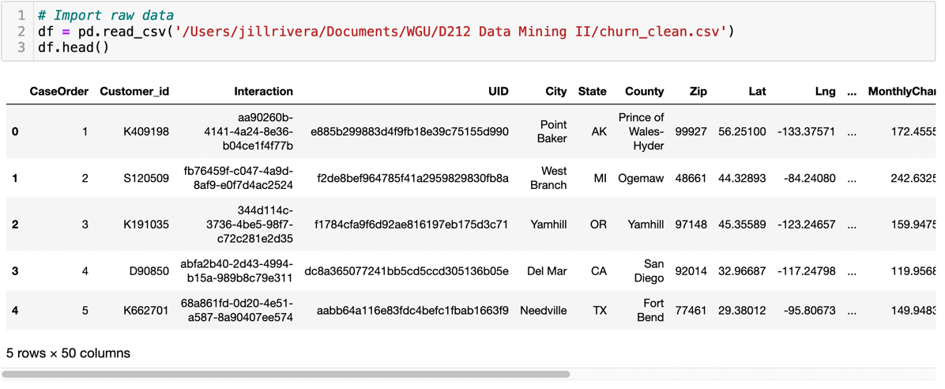

Figure : Importing Data

* 1. Cleaning Data: For this analysis, we have too much data and it needs to be reduced in size before running the calculations. First, the variables that are not helpful to this analysis are removed using the drop function. 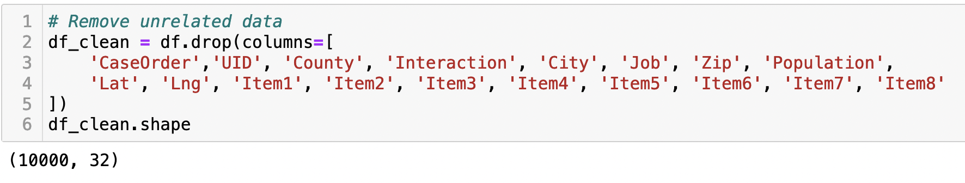

Figure : Removing Unrelated Variables

Next, a separate data frame for only customers who have churned is created by using the location function.

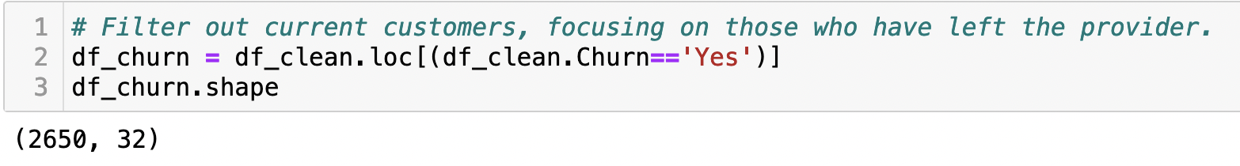

Figure : Filtering for Churned Customers

Now, in keeping true to the assumption of the variables all being continuous numerical in type, another data frame for only numerical data is created. We now have a data frame that is 2,650 rows and five data attributes.

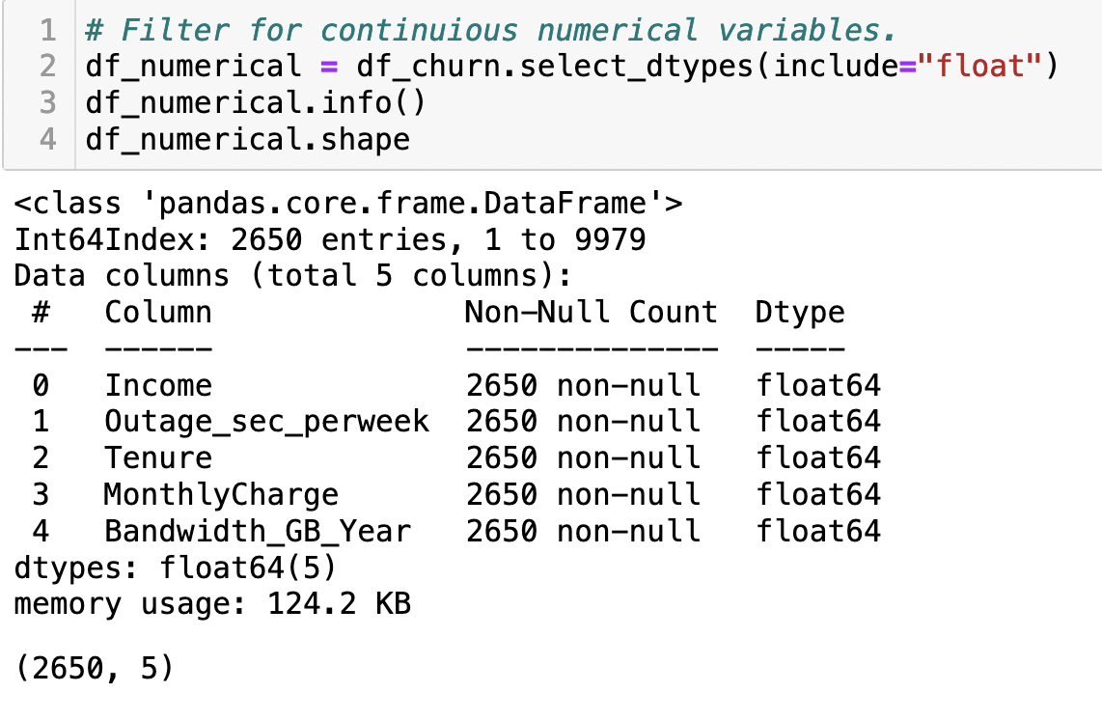

Figure : Filtering for Continuous Numerical Variables

* 1. Exploring Data: Now that the data frame is a more manageable size and consists of only numerical data points on customers who have left the provider, we can explore the data. First, a pair plot is created on the data frame using Seaborn. This plot is used to look at the relationship between each of the variables. For this analysis, those with a linear relationship will be noted as they can skew the results of the calculation.

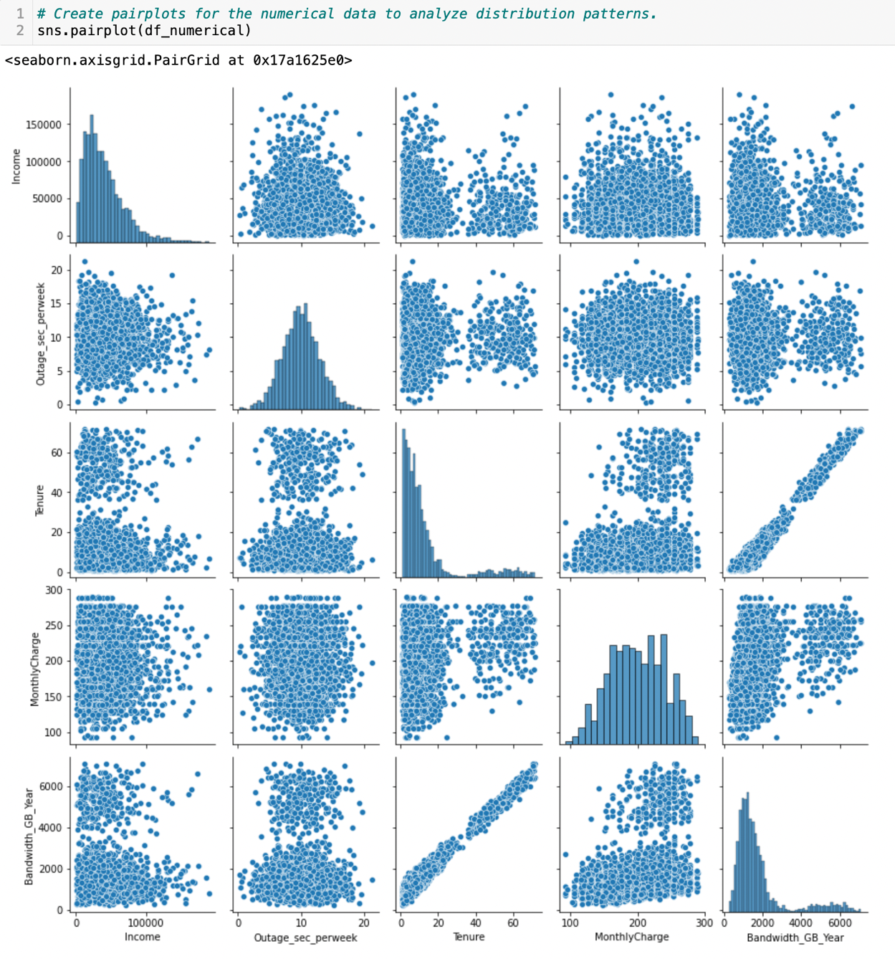

Figure : Pair Plot

Next, the variables are renamed to make the graphs easier to read.

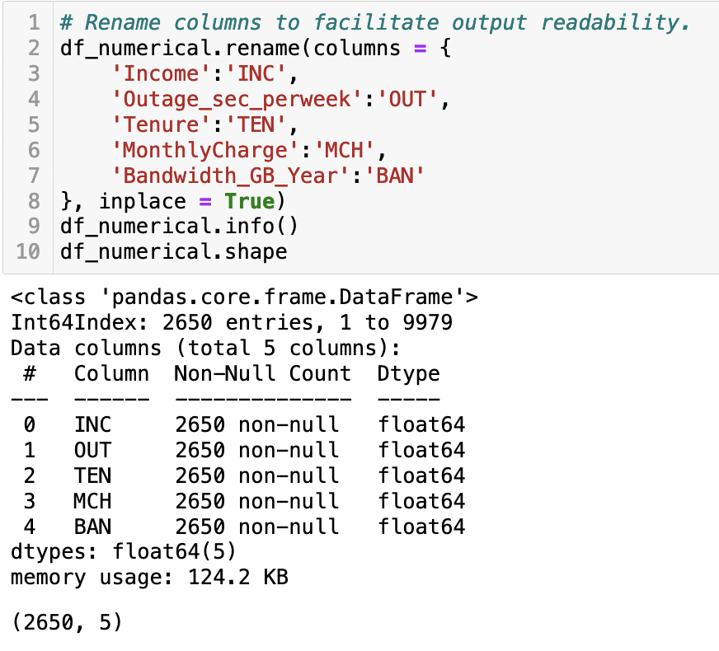

Figure : Rename Variables

The standard metrics of the variables are displayed using the describe method.

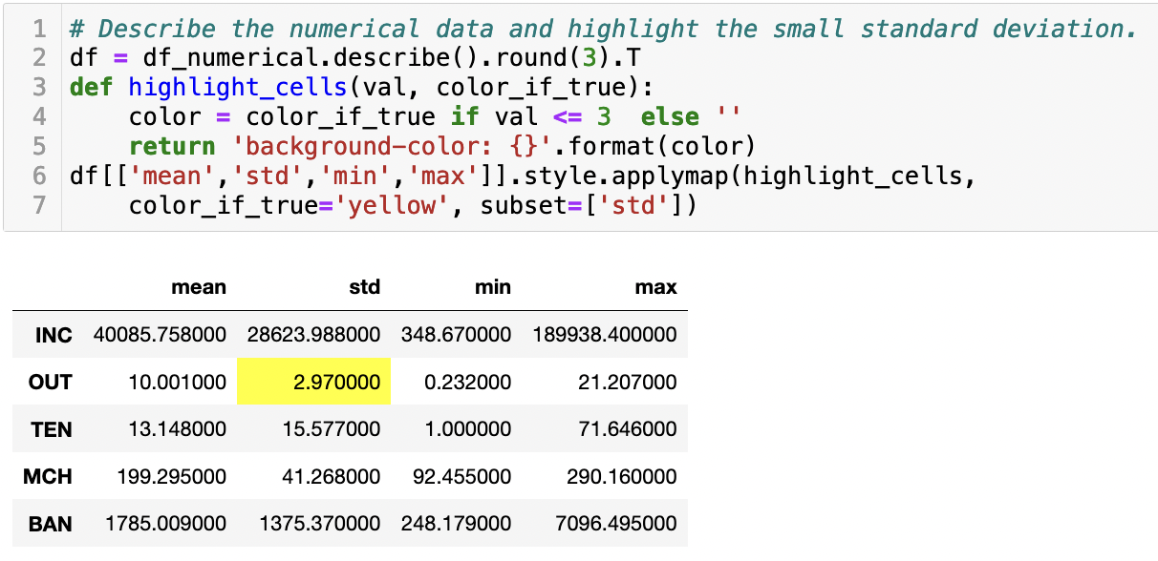

Figure : Variable Standard Metrics

Finally, we verify that all the variables are continuous numerical in type. 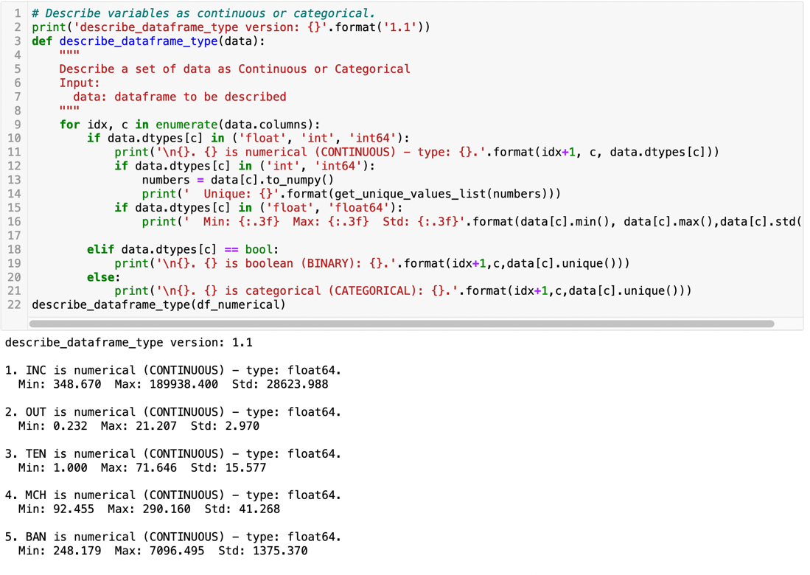

Figure : Variable Data Type

1. Clean Dataset: The data frame that will be used for the analysis is exported from the notebook into a csv file labeled “212clean_task1.csv” using Pandas. This file is attached in this submission for review. 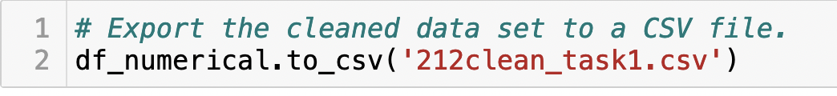

Figure : Exporting Data

# **IV: Analysis**: Clustering analysis is performed and analyzed using the K-Means unsupervised machine learning technique.

# K-means: To begin the K-Means calculations, first the variables which are highly correlated need to be removed. This was determined by the pair plot that was done previously in the data exploration step of the analysis. Since bandwidth and tenure were linear on the pair plot, bandwidth will be removed to reduce the linearity. Text Description automatically generated

Figure : Removing Highly Correlated Variable

# Next, a heatmap is created to verify which variables are highly related to each other.

Figure : Correlation Heatmap

# Then, a scatter plot is created for the two variables which show the highest correlation. The variables of monthly charge and tenure are selected for this from the heatmap.

Figure : Initial Scatter Plot

# A box plot is produced to identify any outlying variables in the data.

Figure : Box Plot of Variables

# When using the K-Means technique, there are two methods to determine the number of clusters that optimizes your model. These methods are the elbow method and the silhouette method. Both will be performed for this analysis. First, the elbow method is performed using the Knee Locator package installed previously. This method shows that three clusters is optimal. Chart, line chart Description automatically generated

Figure : Elbow Method

# Next, performing the silhouette method from Scikit Learn, only two clusters are recommended for the analysis.

Figure : Silhouette Method Determining Cluster Size

# Clustering Analysis: Using the results of the silhouette method, the K-Means clustering analysis is performed using two clusters. Using KMeans from Scikit Learn, the k is set to two and the resulting initial model is created. Chart, scatter chart Description automatically generated

Figure : Initial Model With Two Clusters

# Testing the data using the results of the elbow method is conducted next, setting the k value to three and producing the results shown in the scatter plot.

Figure : Final Cluster Model with Three Clusters

# 

# **V: Data Summary and Implications**: The model is tested for accuracy, limitations and results of the analysis are discussed, and recommendations are made to the provider for future business options.

# Accuracy: The accuracy of the model created can be tested using the Silhouette Analysis Plot. First, the silhouette coefficient is calculated, which is a calculation of how cohesive the data points are for each k. The silhouette coefficient can range from -1 to 1. Interpreting this coefficient, a score close to 0 indicates overlapping of clusters, a value close to -1 shows a very spread-out cluster, and a score close to 1 represents a very compact cluster. (Banerji, 2022) For this analysis, k is maximized at 2 clusters with a coefficient of 0.6092.

Figure : Silhouette Coefficient

Next, Scikit Learn’s packages make_blobs, KMeans, and silhouette_samples, silhouette_score are used to create the silhouette analysis plots for each k. A for loop is used to cycle through the k’s and create the silhouette plots and scatter plots for each. This analysis again verified that two clusters is the optimal number for this data.

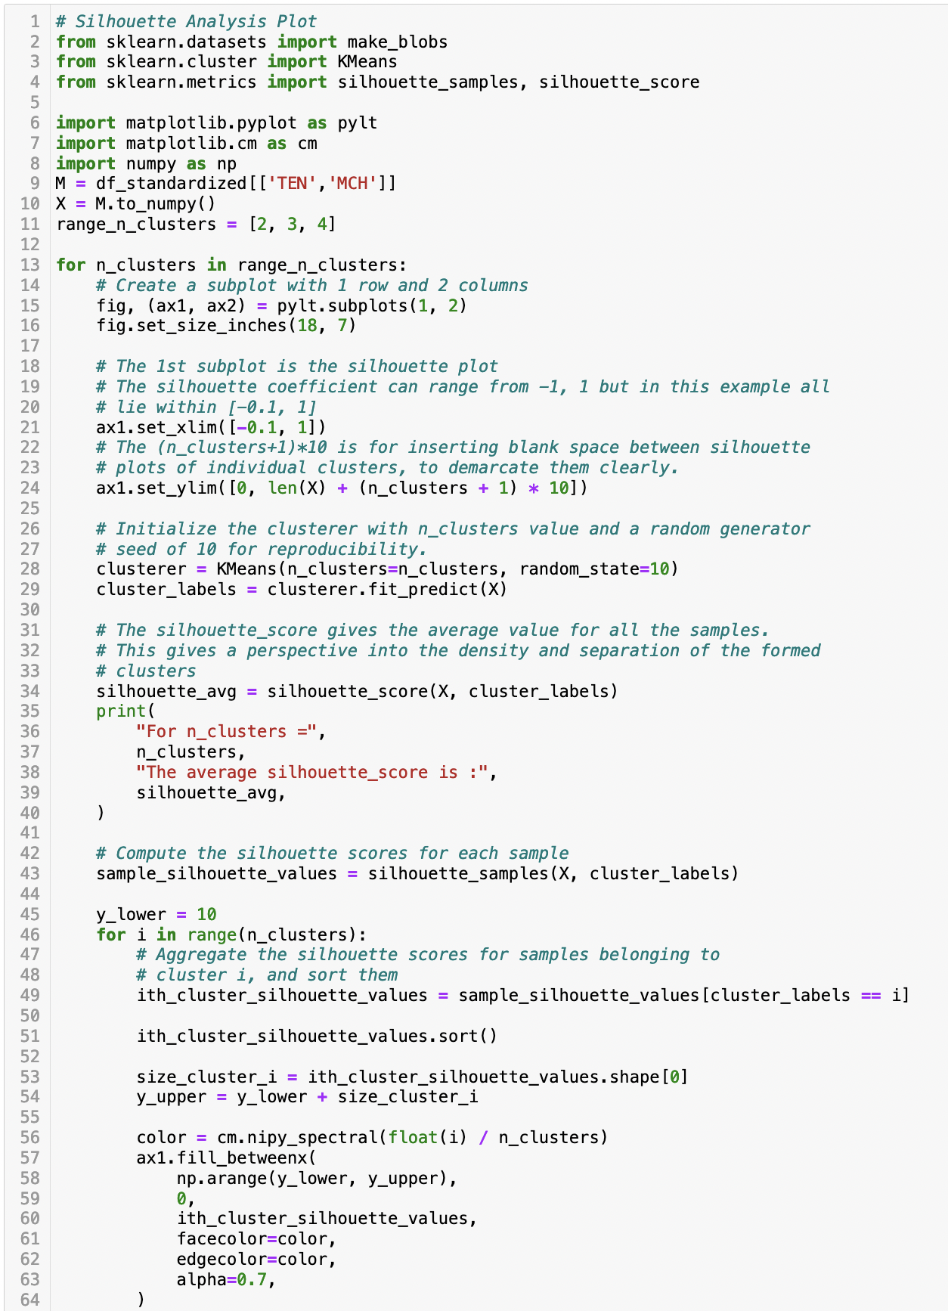

Figure : Silhouette Analysis Plot Code Part 1 (Pedregosa, Varoquaux, & Gramfort, 2022)

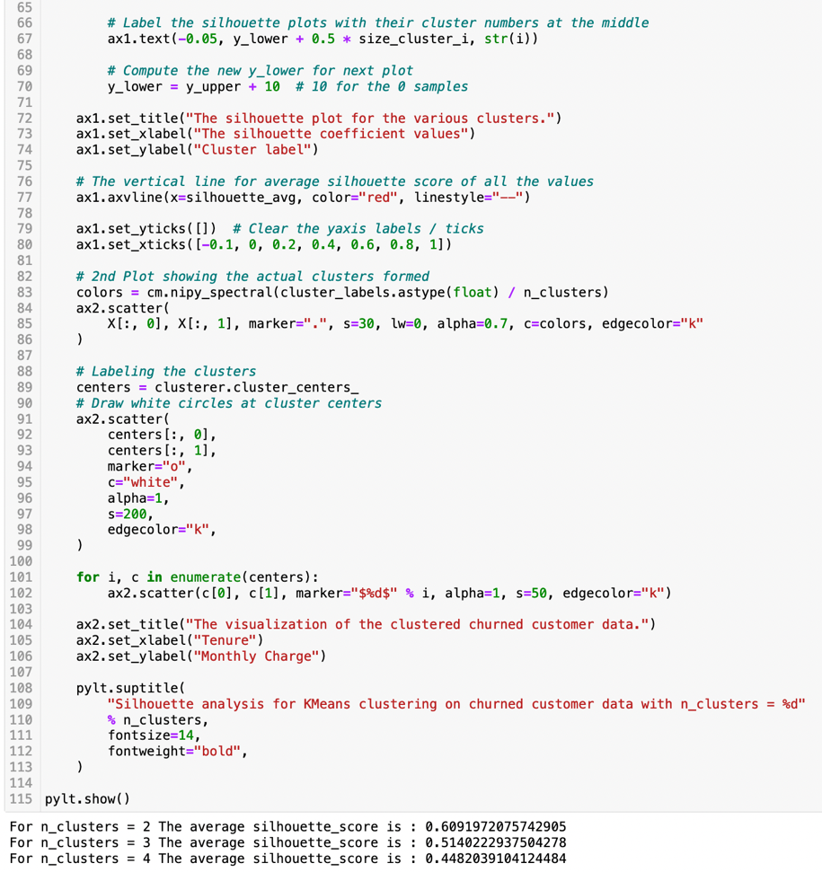

Figure : Silhouette Analysis Plot Code Part 2 (Pedregosa, Varoquaux, & Gramfort, 2022)

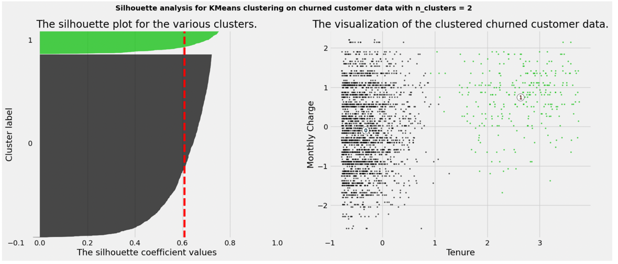

Figure : Silhouette Plot for k=2

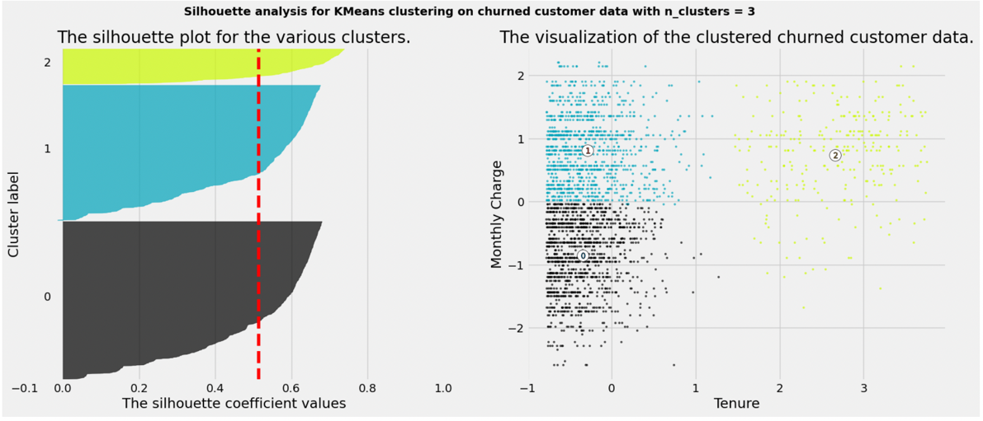

Figure : Silhouette Plot for k=3

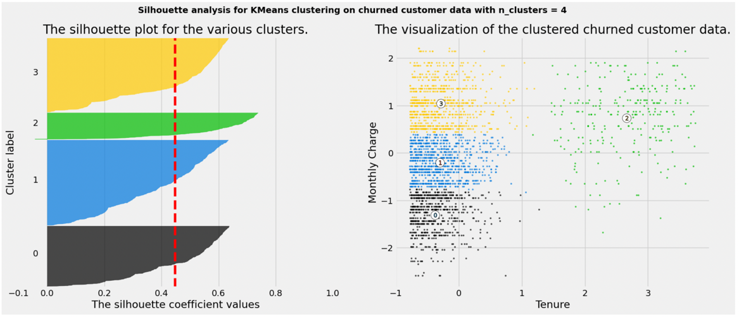

Figure : Silhouette Plot for k=4

# Results: The K-Means analysis showed definite clusters of data points in the analysis. These clusters are highly concentrated, showing that the data points all have a small Euclidian distance from the centroid of the cluster. This suggests that the model is accurate and representative of the data. The variables determined to impact the churned customers in the greatest manner are monthly charge and tenure. The higher the monthly charge and the lower tenure values, equate to the customer discontinuing the service with the provider.

# Limitations: A limitation of the analysis was determining the number of clusters that was best for the analysis. There are two methods that are used in this analysis, and they differ in their results. Diving further into the silhouette method and obtaining the coefficients and creating the silhouette analysis helped to clarify the optimal number of clusters.

# Recommendations: The results of the K-Means analysis showed that a high monthly charge early into a customer’s service is the main factors for their decision to leave the provider. Creating a marketing campaign to target these customers and offer them a discount incentive for remaining with the service would increase the chance of retaining the customer.

# **VI: Works Cited**

(LEDU), E. E. (2018, September 12). *Understanding K-means Clustering in Machine Learning*. Retrieved from Towards Data Science: https://towardsdatascience.com/understanding-k-means-clustering-in-machine-learning-6a6e67336aa1

Banerji, A. (2022, July 19). *K-Mean: Getting The Optimal Number Of Clusters*. Retrieved from Analytics Vidhya: https://www.analyticsvidhya.com/blog/2021/05/k-mean-getting-the-optimal-number-of-clusters/

**VII: Third- Party Code Sources**

Pedregosa, F., Varoquaux, G., & Gramfort, A. (2022, September 22). *sklearn.cluster.KMeans*. Retrieved from Scikit Learn: https://scikit-learn.org/stable/modules/generated/sklearn.cluster.KMeans.html